Increased Risk of Cardiovascular Disease with Vitamin D Deficiency

What is Cardiovascular Disease:
An estimated 800,000,000, American adults, have one or more types of Cardiovascular Disease (1). That equates to one out of every three people in the U.S. who are living with some sort of heart disease. Cardiovascular disease (CVD) affects the heart muscle, the arteries and the veins. The arteries supply blood to the heart. Over time, the arteries become less elastic and harden, due to the formation of plaque. This formation causes inadequate blood flow to the heart. As plaque accumulates in the arteries, there becomes limited or complete blockage of blood flow to the heart. When blood flow is reduced or ceases to be carried to the heart, it also affects the flow of oxygen and nutrients being transported to the heart. This reduced flow of blood, oxygen and nutrients to the heart leads to permanent damage of the actual heart muscle itself.
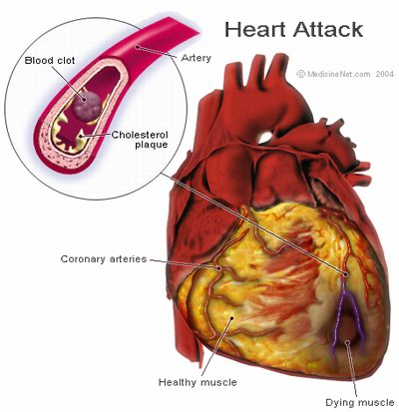
Surgical procedures can aid in repairing arterial walls and increase blood flow back to the heart. However, the long term reduced flow of oxygen and nutrients to the heart can cause permanent damage to the heart muscle and affect the function of the heart forever.
The common risk factors known to lead to CVD are tobacco use, hypertension, diabetes, physical inactivity, age, family history, and gender. The emerging risk factors for CVD are increased C- reactive protein levels, increased thrombosis and fibrinogen, hyperhomocyteinemia, and increased Lp(a) and LDL subclasses levels. The populations most at risk for developing CVD are middle aged to elderly adults, over the age of 60. The best preventive measure against CVD is maintaining a healthy lifestyle of frequent aerobic exercise and a diet rich in essential vitamins, like vitamin D, and unsaturated fats. (1)

What is Vitamin D:
Vitamin D is essential for proper function of the human body. It is a fat-soluble vitamin. The body endogenously absorbs vitamin D through limited foods sources like fatty fish and fortified foods, which include breakfast cereals and milk. Vitamin D is exogenously absorbed through type B UV light. 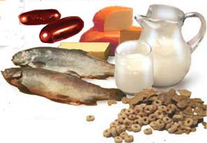
Once absorbed, via endogenously or exogenously, the inactive form of vitamin D is hydroxylated in the liver and changes to its active form 1, 25 hydroxyvitamin D using a variety of organs including the kidney. The active form of vitamin D is then released into the blood stream.
The well-known functions of vitamin D are to maintain bone and muscle health by regulating calcium metabolism, insulin production and functioning as a hormone (3). Maintaining Calcium levels is extremely important, because calcium is vital for nerves and muscles to function. The emerging functions of vitamin D are for arterial wall smooth muscle cell proliferation, reduced inflammation, vascular calcification and blood pressure. Only excessive oral consumption of vitamin D rich foods leads to toxicity and does not occur with excessive sun exposure. (3)

Vitamin D is linked to CVD:
The linkage between vitamin D levels and cardiovascular disease is through the rennin- angiotensin system. The rennin angiotension system regulates blood pressure and water fluid balance in the body. When plasma serum levels are low in vitamin D, 25 hydroxyvitamin D, the body releases higher levels of rennin, which causes arterial constriction. Low levels of vitamin D cause hyperparathyroidism, which is a hormone that releases too much calcium into the bloodstream.
Decreased vitamin D levels in the body have been linked with Hyperparathyroidism and potentially lead to devastating effects and increase the risk for cardiovascular disease. 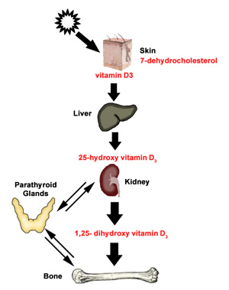 A decrease in 25(OH) D levels will lead to an increase of the parathyroid hormone levels. An increase of these hormone levels will in turn create a deficiency in Vitamin D, which reduces intestinal calcium absorption. When there is a reduction of intestinal calcium absorption, it triggers the parathyroid hormone to release, which repairs the levels of calcium. This occurs because calcium is obtained from the bones and stimulates kidney production of 25(OH) D. In addition to this, levels of vitamin D in the body become lowered overall.
Inflammation causes an increase in calcium blood levels leading to inflammation of arterial walls. The decrease of Vitamin D levels increases the risk of calcification of heart valves due to this increased level of calcium in the blood stream. Also, insulin resistance has been observed with increased PTH levels causing an increase in the risk of developing diabetes…a well known risk factor for CVD. A low level of 25(OH) D along with increased PTH levels increases inflammation and increases the risk of cardiovascular disease. (3)
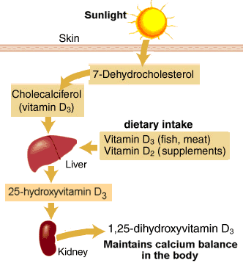
Measuring Vitamin D Levels:
The suggested plasma serum vitamin D levels that reduce the risk of arterial constriction are 37 ng/ mL or greater; these are suggested to lead to additional health benefits including reducing the risk for CVD. The defined vitamin D levels that increase risk are suggested to be 20 ng/mL or lower. To determine the level of risk of CVD from low Vitamin D Serum levels, a standard blood test prescribed by a physician should be requested. (4)

Correlated studies:
Developing Cardiovascular Disease Risk Factors:
A 2007 study published in the Archives of International Medicine reported an association between vitamin D and cardiovascular disease risk factors. In the study, 7,186 men and 7,902 women over the age of twenty had their blood measured for levels of 25(OH) D. The mean of 25 (OH) D levels was 30 ng/ml. The current recommended levels of serum 25 (OH) D are based on levels needed to maintain optimum bone health and prevent rickets, but does not address the amount of vitamin D to minimize the risk of cardiovascular disease.
The research hypothesized that individuals with reduced 25(OH) D levels would have an increased risk of cardiovascular disease. The participants studied were currently not taking vitamin D supplements. The distribution of vitamin D levels in the body may have been skewed in some participants due to varying latitudes altering the measurements slightly of the 25 (OH) D collected and analyzed. It was found that higher levels of UV light exposure were a better predictor for having higher levels of vitamin D absorption. The blood analyses found 25(OH) D levels were lower in women, racial minorities, and people with obesity, hypertension, diabetics and elderly older than sixty years of age.
The study included measured levels of the participants’ BMI, blood pressure and 25(OH) D. Data was collected from the participants based on age, ethnicity, sex, blood pressure level, history of hypertension, blood glucose, lipid levels, history of diabetes, and body mass index. The participants’ blood samples were measured for blood glucose, total cholesterol, serum triglyceride, serum albumin and glomerular filtration rate.
The results of the study found that participants with high blood pressure, a systolic pressure greater than or equal to 140, and a diastolic pressure greater than or equal to 90, were at 30% increased risk for cardiovascular disease. Both male and females that had a BMI greater > 30 are 229% more likely to develop cardiovascular disease. Participants with a history of diabetes and triglyceride levels > 150 mg/dl are susceptible to inheriting risk of cardiovascular disease. The study also found participants with non-HDL cholesterol levels >150 or total cholesterol levels >240 are less likely to developing risk factors of cardiovascular disease.
Overall, an increased blood pressure, history of diabetes, BMI >30 and high triglyceride levels lead to participants with greater risk of developing risk of cardiovascular disease. However, the correlation between vitamin D linked and risk factors for developing cardiovascular disease show that participants with increased levels of vitamin D lower the risk of developing cardiovascular disease. (4)
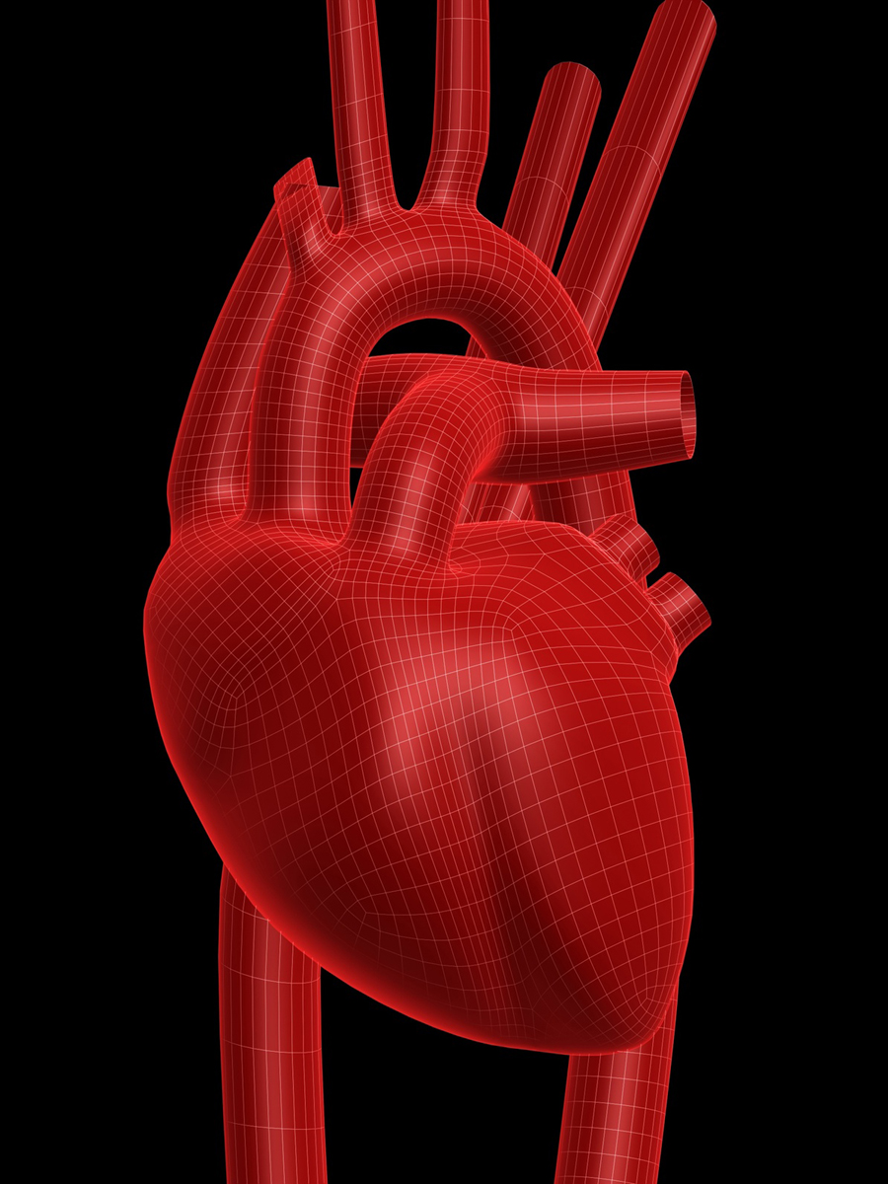
Cardiovascular Outcomes:
A 2008 article published in Circulation demonstrated a strong link between Vitamin D deficiency and an increased risk for developing cardiovascular disease. The epidemiological study, from the Framingham Offspring was started in 1971, which followed a group of white males and females linked to the Boston University Medical Center and Tufts-New England Medical center. The participants were studied based on natural life progression of diseases linked to Vitamin D levels. Between 1996 and 2001,a total of 1,739 participants returned for observation. They had additional laboratory and health assessments tests that pertained to cardiovascular health.
Each participant was assessed for common risk factors linked with cardiovascular disease, including: age, gender, blood pressure, and blood glucose; along with blood vitamin D serum levels. The samples collected were analyzed based on the following standards: Hypertension, > 140mm Hg, diastolic blood pressure, > 90mm Hg, and blood sugar levels, >126 mg/dL. Vitamin D, 25 dihydroxyvitamin D (25 (OH) D), was tested based a determined scale of: <10ng/mL as low, > 15ng/mL as medium and > 30ng/mL as high and optimal levels. The serum 25 (OH) D was used as the most accurate reading of Vitamin D levels in the body as it represents both the endogenous and exogenous levels absorbed by dietary intake and exposure to sunlight.
The other basic health assessments included a lifestyle estimate of sun exposure, physical activity levels, and detailed food frequency questionnaires.
The results first analyzed the risk for outcomes of cardiac events, which included myocardial infarction, coronary insufficiency, angina, stroke, transient ischemic attack, peripheral claudicating or heart failure. The results were based on the true risk of experiencing a cardiac event with age and sex as the control factors. The findings were significant, having a 66% increase in risk after adjustment for clinical covariates and CRP levels of a cardiac event when the participant had 25 (OH) D levels below <15ng/mL. The risk of a cardiac event occurring further increased to 88% with low 25 (OH) D, <10 ng/Ml. The second aspect of the research analyzed the added risk of hypertension accompanying 25 (OH) D levels on the occurrence of a cardiac event. The results found in participants with 25 (OH) D levels of <15ng/mL the risk was dramatically higher, increasing from 66%, in participants without hypertension, to 219%, in participants with hypertension.

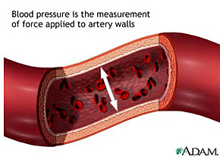
The risk of a cardiac event increased another 24% to 243% risk of a cardiac event with participants having both 25 (OH) D levels <10ng/mL and hypertension. The results found a linear trend with increased risk of a cardiac event with hypertension and decreased 25 (OH) D levels; the analysis demonstrates that the participants with the combination of hypertension and low 25 (OH) D levels are at very high risk for experiencing a cardiac event.
The study found after adjustment for conventional cardiovascular risk factors, that there was still a significant link between 25 (OH) D and an increased risk for cardiovascular disease. The findings indicate that 28% of participants had serum average levels of 25 (OH) D of 19.6ng/mL; this indicated a number lower than optimal vitamin D levels but still within adequate range, with only 9% below 10 ng/mL. The study also found that the participants with hypertension had a 2-fold increased risk for cardiovascular disease if low vitamin D serum levels accompanied the hypertension. It was observed that low levels of vitamin D occurring before cardiovascular problems had a high linkage to an increased risk of developing heart problems more rapidly. These heart problems included stroke, heart failure, and acute myocardial infraction.
Overall, the study found a nonlinear relationship of cardiovascular disease and low vitamin D serum levels below 15 to 20 ng/mL; showing a strong linkage of risk for heart disease and cardiac events with low vitamin D levels. (5)

Conclusion:
The conclusion to the studies showed that diets including adequate vitamin D levels, reduces arterial constriction and release of rennin; thus ultimately reducing the risk of CVD. The studies also found that patients with low plasma serum vitamin D levels showed overall health improvement and had reduced risk of CVD. (2,3, 4, 5, and 6)
Recommendations for further studies:
The studies support further long-term research surrounding Vitamin D and its relationship to the reduction of CVD and arterial health, including constriction and proliferation. The negative aspect of the studies showed no current epidemiological research surrounding Vitamin D and CVD specifically, and did not take into account different ethnicities and populations with no prior kidney damage or failure previous to the study.

List of Reference
1. American Heart Association. www.americanheart.org. 2009

2. Hur SJ, Kim DM, Lim KH, et al. Vitamin D Levels and Their Relationship with Cardiac Biomarkers in Chronic Hemodialysis Patients. J of Korean Medicine.2009; 24(1): 109-114

3. Lee JH, Bell D, et al. Vitamin D Deficiency: An important, Common, and Easily Treatable Cardiovascular Risk Factor. Journal of American College of Cardio, 2008; 52: 1949-1956

4. Martin D, Myles W, Pan D, et al. Prevalence of Cardiovascular Risk Factors and the Serum Levels of the 25 Hydroxyvitamin-D in the United States. AMA. 2007; 167: 1159-1165.

5. Wang TJ, Pencina MJ, Booth SL, et al. Vitamin D Deficiency and Risk of Cardiovascular Disease. AHA. 2008; 117:1-9

6. Wang AY, Lam CW, Sanderson JE, et al. Serum 25- Hydroxyvitamin D and Cardiovascular Outcomes in Chronic Peritoneal Dialysis: a 3-y prospective cohort study. The American Journal of Clinical Nutrition. 2008; 87: 1631-1638.

